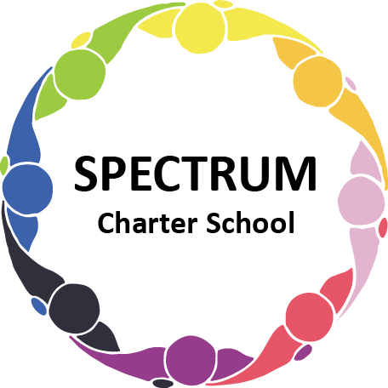

BOARD OF TRUSTEES DISCUSSION AND VOTING MEETING AGENDA
October 19, 2022

DATE: October 19, 2022 TIME: 7:00 PM
LOCATION: Spectrum Charter School- virtual via Google Meet
CEO: Dr. Matthew Erickson

DISCUSSION/VOTING AGENDA ITEMS

- Call to order:

- Pledge of Allegiance

- Roll call:

Approval to accept the September 21, 2022 Board of Trustee Meeting Minutes as presented.
The Board Met in Executive Session on the following date: October 19, 2022. Personnel and Student Matters were discussed.

- Public Comments on Agenda Items:
- Board Discussion

- CEO/Principal Report:
A. Safety Drills/Visit with Chief Cole
B. Fall Dance - 10/28/22
C. Student Council
D. Parent/Student Handbook Revisions
E. Transportation Update
F. Forbes Career and Technical Center Update
G. Parent Training Series: Autism: 10/20/22 - 6:00 pm - 7:15 pm

VII. Personnel Committee Agenda Items:
A. Recommendation to approve the following:
1. Request to post a Food Service Position (Part-Time) for Spectrum Charter School
2. Social Work/Behavior Specialist Request for Proposals
3. Westinghouse Arts Charter School Agreement (Physical Education)
B. Board Action:

VIII. Finance Committee Agenda Items:
  - Monthly Financial Reports:
    - YTD Activity
    - Tuition aging report
    - Activity Report
    - Budget Vs. Actual
    - Cash Flow
  - Monthly purchase review:
- Amazon orders
- Visa Bills
C. Board Action: Approval to pay bills due through November

IX. Fundraising/Grants Committee Agenda Items:

- Give Big Pittsburgh November 29, 2022
- Open House
1. Letter
2. Flyer

X. Facilities Report
- Website Status
- Food service update
- Van Update
- Building Improvements
- Grant Purchases and Bidding

XI. Public Comments on non-Agenda Items:

XII. Announcements:

XIII. Next Meeting: November 16, 2022; 7:00 pm; Spectrum Charter School & Google Meet

XIV. Motion to Adjourn:

