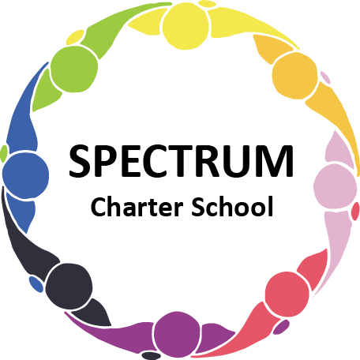

BOARD OF TRUSTEES DISCUSSION AND VOTING MEETING AGENDA
OCTOBER 20, 2021

DATE: October 20, 2021 TIME: 7:00 PM
LOCATION: Zoom Meeting
CEO: Dr. Gail Yamnitzky

DISCUSSION AGENDA ITEMS

- Call to order:

- Pledge of Allegiance

- Roll call

- Public comments on Agenda items

- Academic Committee Agenda items
  - Waterfront Learning Services Contract

- Finance Committee Agenda items
  - Financial Report
  - House demolition contract - Allen Demolition Co., LLC Move to vote ꗃ
  - Snow removal proposals
Stockman’s
Dojonovic’s
  - Design 3 Architectural Service for house remodel proposal Move to vote ꗃ
  - Annual Audit
  - AFR
  - 990

- Marketing/Grants Committee Agenda items
  - Safe Schools Grant request; $25,000 for safety and security updates
  - American Heart Association Community Grant request; $3000 for fencing for the garden
  - Walmart Grant request; $250-$5000; general
  - Sam’s Club Grant request; $250-$5000; general
  - Lawrence Foundation request; $5000; general

- Personnel Committee Agenda items
  - Status of hiring paraprofessionals
  - Contract with Grade Point Resources to hire 2 paraprofessionals/personal care aides - Cost comparison

- Policy Committee Agenda items
  - 815.3 Children’s Internet Protection Act Move to vote ꗃ
  - 226.1 Students’ Rights Move to vote ꗃ
  - 805.1 Lockdown and Shelter in Place Move to vote ꗃ
  - 004 Board Orientation Move to vote ꗃ
  - 815 Acceptable Use and Internet Safety Move to vote ꗃ

- Public comment on non-Agenda items

- Motion to adjourn

VOTING AGENDA ITEMS

- Call to order:

- Roll call

Approval to accept the September 15, 2021 Board of Trustees Meeting minutes as presented.

- Public comments on Agenda items

- Academic Committee Agenda items

- Finance Committee Agenda items
  - Approval of Monthly Budget Report
  - Approval to pay the bills due through November
  - Approval to contract with Allen Demolition Co. LLC. to demolish the 4373 Northern Pike property at a cost of $9000.00

- Fundraising/Grants Committee Agenda items

- Personnel Committee Agenda items
  - Approval to contract with Grade Point Resources to hire two paraprofessional/personal care aides

- Policy Committee Agenda items
  - Motion to approve the following policies
    - 815.3 Children’s Internet Protection Act
    - 226.1 Students’ Rights
    - 805.1 Lockdown and Shelter in Place
    - 004 Board Orientation
    - 815 Acceptable Use and Internet Safety

- Public comment on non-Agenda items

- Announcements
  - October 26, 2021 - End of 1st Grading Period
  - Parent Teacher Conferences (virtual) - November 3, 4 and 5

- Next meeting: November 17, 2021; 7:00 pm; location to be determined

- Motion to adjourn

