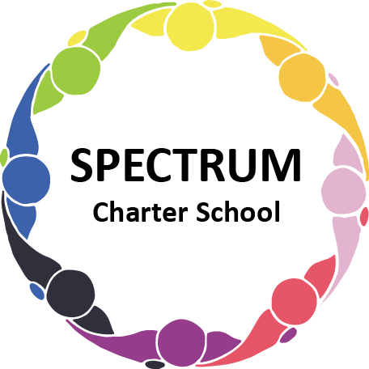

BOARD OF TRUSTEES DISCUSSION AND VOTING MEETING AGENDA
November 16, 2022

DATE: November 16, 2022 TIME: 7:00 PM
LOCATION: Spectrum Charter School- virtual via Google Meet
CEO: Dr. Matthew Erickson

DISCUSSION/VOTING AGENDA ITEMS

- Call to order:

- Pledge of Allegiance

- Roll call:

Approval to accept the October 19, 2022 Board of Trustee Meeting Minutes as presented.
The Board Met in Executive Session on the following dates: November 7, 2022 and November 16, 2022. Personnel Matters were discussed.

- Public Comments on Agenda Items:

- CEO/Principal Report:
  - Veteran’s Day Event
  - Halloween Dance
  - Adaptive Golf Event
  - Student Council Elections
  - Parent Trainings
- Administrative
  - Board meeting schedule: Dec. 5, 2022

VII. Personnel Committee Agenda Items:
A. Business Manager
B. Assistant Business Manager Title
1. Discussion
2. Board Action
C. RFP - Behavior Specialist
D. Compensation
1. Discussion
- Teacher increase: $7,000.00
- Support Staff increase: $5,000.00
- Transition Support: $5,000.00
- Paraprofessional increase: $1,000.00
2. Board Action

VIII. Finance Committee Agenda Items:
- Monthly Financial Reports:
    - YTD Activity
    - Tuition aging report
    - Expense Report
    - Budget Vs. Actual
    - Cash Flow
B. Monthly purchase review:
- Amazon orders
- Visa Bills
C. Annual Financial Report
D. Board Action: Approval to pay bills due through December

IX. Fundraising/Grants Committee Agenda Items:
- Give Big Pittsburgh 11/29/22
  - Website
  - Social Media

X. Monroeville Police Department MOU
A. Board Discussion
B. Board Action

XI. Facilities Report
- Sale of Honda Van for $5,300
- Grant Purchases
  - Bollards
  - Security Cameras
  - Window Film
  - Metal Doors
  - Raptor Visitor system
- Wheelchair Ramp estimate
- Food service agreement
- Air quality upgrade
- Mold inspection
- Board Action: Approve contract for food service, sale of vehicle and wheelchair ramp

XII. Public Comments on non-Agenda Items:

XIII. Announcements:

- Thanksgiving Break: Nov. 24, 25, 28, 2022

XIV. Next Meeting (Annual Meeting): December 7, 2022; 7:00 pm; Spectrum Charter School & Google Meet

XV. Motion to Adjourn:

