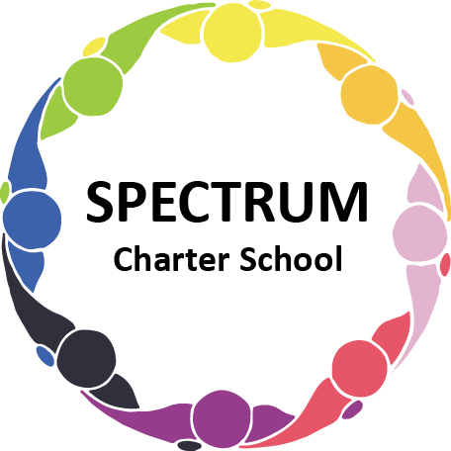

BOARD OF TRUSTEES DISCUSSION AND VOTING MEETING AGENDA
NOVEMBER 17, 2021

DATE: November 17, 2021 TIME: 7:00 PM
LOCATION: Zoom Meeting
CEO: Dr. Gail Yamnitzky

DISCUSSION AGENDA ITEMS

- Call to order:

- Pledge of Allegiance

- Roll call

- Public comments on Agenda items

- Academic Committee Agenda items
  - Four Pittsburgh Public School students without rides
  - Mask mandate lifted January 17, 2022; (Potentially moving to December 4, 2021)

- Finance Committee Agenda items
  - Monthly Financial Report
  - 990 filed and accepted per Peter - attending December Meeting
  - Update on Demo project
  - Water line issue
  - Monthly VISA bills for review
    - Bill #1
    - Bill #2
    - Bill #3

- Marketing/Grants Committee Agenda items
  - Walmart - $1000 grant
  - 5K Race update
  - Update on DEP Grant

- Personnel Committee Agenda items
  - Review of contract with Grade Point Resources and hiring progress
  - Staff member is Covid-19 close contact
  - Covid protocol

- Policy Committee Agenda items
  - 815.3 Children’s Internet Protection Act Move to vote ꗃ
  - 226.1 Students’ Rights Move to vote ꗃ
  - 805.1 Lockdown and Shelter in Place Move to vote ꗃ
  - 004 Board Orientation Move to vote ꗃ
  - 815 Acceptable Use and Internet Safety Move to vote ꗃ

- Public comment on non-Agenda items

- Motion to adjourn

VOTING AGENDA ITEMS

- Call to order:

- Roll call

Approval to accept the October 20, 2021 Board of Trustees Meeting minutes as presented.

- Public comments on Agenda items

- Academic Committee Agenda items
  - Motion to lift/maintain mask mandate
  - Motion to approve Charter Renewal

- Finance Committee Agenda items
  - Motion to approve Monthly Financial Report
  - Motion to pay the bills due through December

- Fundraising/Grants Committee Agenda items
  - Motion to accept $1000 grant from Walmart

- Personnel Committee Agenda items
  - Motion to accept the resignation of Dr. Gail Yamnitzky effective December 31, 2021

- Policy Committee Agenda items
  - Motion to approve the following policies
    - 815.3 Children’s Internet Protection Act
    - 226.1 Students’ Rights
    - 805.1 Lockdown and Shelter in Place
    - 004 Board Orientation
    - 815 Acceptable Use and Internet Safety

- Public comment on non-Agenda items

- Announcements
  - Thanksgiving Break is November 25 through November 29, 2021
  - We will be collecting donations of new or gently used items for a Holiday Shop for students to be held on December 17, 2021
  - We will be collecting monetary donations for our Giving Tree to purchase gift cards for students in need

- Next meeting:, December 15, 2021; 7:00 pm; location to be determined

- Motion to adjourn

