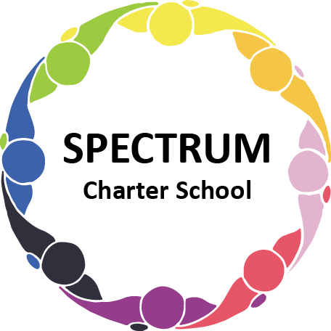

BOARD OF TRUSTEES DISCUSSION AND VOTING MEETING AGENDA
December 5, 2022

DATE: December 5, 2022 TIME: 7:00 PM
LOCATION: Spectrum Charter School- virtual via Google Meet
CEO: Dr. Matthew Erickson

DISCUSSION/VOTING AGENDA ITEMS

- Call to order:

- Pledge of Allegiance

- Roll call:

Approval to accept the November 16, 2022 Board of Trustee Meeting Minutes as presented.

- Public Comments on Agenda Items:

- CEO/Principal Report:
- Interviews
- Thanksgiving
- Toys for Tots
- Food Services
- Administrative
  - Board of Trustee Reelection
- Approval to reelect Dorice Tharp to a three-year term as a Board of Trustees member, Spectrum Charter School commencing Dec. 5, 2022
- Approval to reelect Ellen Szczerba to a three-year term as a Board of Trustees member, Spectrum Charter School commencing Dec. 5, 2022

B. Annual Reorganization
- Nominations for President: Michele Gutman
- Nominations for Vice President: Barbara Bain
- Nominations for Secretary: Dorice Tharp
- Nominations for Treasurer: Dorice Tharp

- Revisions to 2022-2023 Board meeting schedule
- Revised Schedule
1. Board Action

VIII. Personnel Committee Agenda Items:
A. Revised Contracts
1. Board Action
- Employment of Teacher
- Board Action

IX. Finance Committee Agenda Items:
- Monthly Financial Reports:
    - Expense Report
B. Monthly purchase review:
- Amazon orders
- Visa Bills
C. Annual Financial Report Review
D. Board Action: Approval to pay bills due through January
E. Food Service Director Role - Job Description/Role

X. Fundraising/Grants Committee Agenda Items:
- Give Big Pittsburgh 11/29/22
- Direct Donations

XI. Facilities Report
- Wheelchair ramp complete
- Update on PCCD grant
- Website Update/Demonstration

XII. Student Council Officers
- Elected positions

XIII. Public Comments on non-Agenda Items:

XIV. Announcements:

- Holiday Break: December 23-30 and January 2, 2023
- Toy Donation Drive

XV. Next Meeting: January 17, 2023; 7:00 pm; Spectrum Charter School & Google Meet

XVI. Motion to Adjourn:

