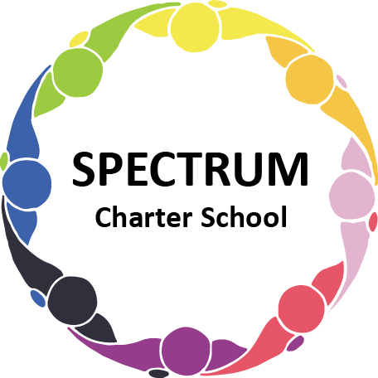

BOARD OF TRUSTEES DISCUSSION AND VOTING MEETING AGENDA
DECEMBER 15, 2021

DATE: December 15, 2021 TIME: 7:00 PM
LOCATION: Zoom Meeting
CEO: Dr. Gail Yamnitzky

DISCUSSION AGENDA ITEMS

- Call to order:

- Pledge of Allegiance

- Roll call

- Public comments on Agenda items

- Academic Committee Agenda items
  - Mid-year assessments update
  - Autism Connection

- Finance Committee Agenda items
  - Annual Audit Report update - Peter
  - Monthly Financial Reports
  - Update on Demo project
  - Water line update
  - Monthly VISA bills for review
    - Amazon orders
      - November
      - December

- Marketing/Grants Committee Agenda items
  - Giving Tuesday update - $1600+
  - Grant update
    - $500 grant for T-shirts from 4Imprint

- Personnel Committee Agenda items

- Policy Committee Agenda items
  - Employee Complaint Policy 326.2

- Public comment on non-Agenda items

- Motion to adjourn

VOTING AGENDA ITEMS

- Call to order:

- Roll call

Approval to accept the November 17, 2021 Board of Trustees Meeting minutes as presented.
The Board met in Executive Session on XXXX to discuss personnel.

- Public comments on Agenda items

- Annual Reorganization
  - Nominations for President
  - Nominations for Vice President
  - Nominations for Secretary
  - Nominations for Treasurer

- Academic Committee Agenda items

- Finance Committee Agenda items
  - Motion to approve Monthly Financial Report
  - Motion to pay the bills due through January

- Fundraising/Grants Committee Agenda items

- Personnel Committee Agenda items

- Policy Committee Agenda items
  - Motion to approve the following policies
    - Employee Complaint Policy 326.2

- Public comment on non-Agenda items

- Announcements
  - The Thanksgiving Turkey Fund served three families
  - Giving Tree

- Next meeting: January 12, 2022; 7:00 pm; location to be determined

- Motion to adjourn

