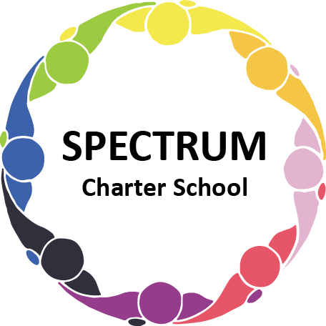

BOARD OF TRUSTEES DISCUSSION AND VOTING MEETING AGENDA
APRIL 21, 2021

DATE: April 21, 2021 TIME: 7:00 PM
LOCATION: Spectrum Charter School - virtual via Zoom
CEO: Dr. Gail Yamnitzky

DISCUSSION AGENDA ITEMS

- Call to order:

- Pledge of Allegiance

- Roll call

- Public comments on Agenda items

- Academic Committee Agenda items
  - Addition of “Personal Finance” elective Move to vote

- Finance Committee Agenda items
  - Monthly Budget Report Move to vote
  - Financial reports overview
  - Contract with Republic Services Move to vote
  - Preliminary Budget 2021-2022 Move to vote
  - Proposal for 2020-2021 Audit from Hosack, Specht, Muetzel & Wood LLP
Move to vote

- Marketing/Grants Committee Agenda items
  - NGPF Grant for $1000 for new curriculum Move to vote
  - Mock ups for new brochure
    - Style 1
    - Style 2 - Multi-color
    - Style 2
    - Style 3

- Personnel Committee Agenda items

- Policy Committee Agenda items
  - Policy 610 Purchases Subject to Bid Move to vote
  - Policy 209 Health Examinations Move to vote
  - Policy 251.1 Surrogate Parents Move to vote

- Public comment on non-Agenda items

- Motion to adjourn

VOTING AGENDA ITEMS

- Call to order:

- Roll call

- Public comments on Agenda items

- The Board met in Executive Session on Wednesday, April 21, 2021 to discuss matters of personnel.

- Approval of March 17, 2021 Board Meeting Minutes

- Academic Committee Agenda items
  - Approval to add a new course: Personal Finance, as a semester long elective

- Finance Committee Agenda items
  - Approval of the Monthly Budget Report
  - Approval to pay upcoming bills
  - Approval to remove Michelle Johnson and add Scott Domowicz as a signer to Spectrum Charter School’s PNC and FNB bank accounts
  - Approval of Contract with Republic Services
  - Approval of Proposal to complete 2020-2021 audit by Hosack, Specht, Muetzel & Wood LLP

- Marketing/Grants Committee Agenda items
  - Approval to accept NGPF Grant for $1000 for new curriculum in Personal Finance

- Personnel Committee Agenda items

- Policy Committee Agenda items
  - Approval of the following policies:
    - Policy 610 Purchases Subject to Bid
    - Policy 209 Health Examinations
    - Policy 251.1 Surrogate Parents

- Public comment on non-Agenda items

- Announcements
  - Carnival-themed walk - April 30
  - Safety Day; May 21
  - Graduation; Thursday, May 27; 11:00 am; lunch included

- Next meeting: May 19, 2021; 7:00 PM

- Motion to adjourn

