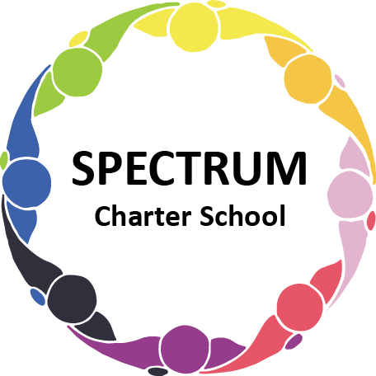

BOARD OF TRUSTEES DISCUSSION AND VOTING MEETING AGENDA
May 18, 2022

DATE: May 18, 2022 TIME: 7:00 PM
LOCATION: Spectrum Charter School- virtual via Google Meet
CEO: Dr. Matthew Erickson

DISCUSSION AGENDA ITEMS

- Call to order:

- Pledge of Allegiance

- Roll call:

- Public Comments on Agenda Items:

- CEO/Principal Report:

- Academic Committee Agenda Items:
  - AIU Annual Agreement Move to vote ꗃ
  - AIU Annual Pricing Guide
  - AIU Annual Services Guide
  - Access Billing
  - Cyclical Monitoring Update
  - Comprehensive Plan Draft/Public Posting

- Finance Committee Agenda Items:
  - River Therapies Contract Move to vote ꗃ
  - Technology Service Proposal
  - Monthly Financial Reports:
    - YTD Activity
    - Tuition aging report
    - Activity Report
    - Budget Vs. Actual
    - Cash Flow
  - Monthly purchase review:
- Amazon orders
- Visa Bills
E. Proposed Final Budget
- PDE-2028
F. Marketing - 32 Creative
- Proposal
- Billboards- Monroeville, Murrysville
G. Website Proposal

H. Van Repair

I. Revised Bank Proposal

- Fundraising/Grants Committee Agenda Items:
A. Fundraising
1. Letters to individual donors
2. Heinz Foundation

- Facilities Report
- Status report/Proposed plan for building projects
- Zoning of House

- Personnel Committee Agenda Items:

- Policy Committee Agenda Items:
- Health and Safety Plan Revision Move to vote ꗃ

- Public Comments on non-Agenda Items:

- Motion to Adjourn:

VOTING AGENDA ITEMS

- Call to Order:

- Roll Call:

Approval to accept the April 25, 2022 Board of Trustees Meeting minutes as presented.
The Board met in Executive Session on the following date: May 18, 2022. Personnel matters were discussed.

- Public Comments on Agenda Items:

- Academic Committee Agenda Items:
- Motion to approve AIU Annual Agreement

- Finance Committee Agenda Items:
  - Motion to approve Monthly Financial Reports
  - Motion to pay the bills due through June
  - Motion to approve River Therapies Contract

- Fundraising/Grants Committee Agenda Items:

- Facilities Report:

- Personnel Committee Agenda Items:

- Policy Committee Agenda Items:
- Motion to approve Health and Safety Plan Revision

- Public Comments on non-Agenda Items:

- Announcements:

- Next Meeting: June 15, 2022; 7:00 pm; Spectrum Charter School & Google Meet

- Motion to Adjourn:

