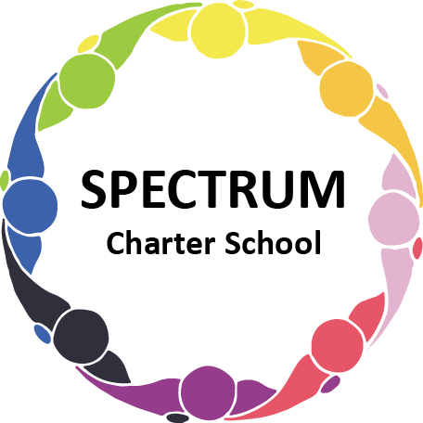

BOARD OF TRUSTEES DISCUSSION AND VOTING MEETING AGENDA
JUNE 16, 2021

DATE: June 16, 2021 TIME: 7:00 PM
LOCATION: Spectrum Charter School - virtual via Zoom
CEO: Dr. Gail Yamnitzky

DISCUSSION AGENDA ITEMS

- Call to order:

- Pledge of Allegiance

- Roll call

- Public comments on Agenda items

- Academic Committee Agenda items
  - Enrollment update
  - Comprehensive Plan update
  - Garden
  - AIU Annual Agreement Move to vote
  - AIU Annual Pricing Guide
  - AIU Annual Services Guide

- Finance Committee Agenda items
  - Monthly Budget Report Move to vote
  - GFB 2021-2022 Move to vote
  - Quote for IT Services from Empower Move to vote
  - Cyber Insurance
  - Boiler update

- Marketing/Grants Committee Agenda items
  - Highmark Grant - $7200.00

- Personnel Committee Agenda items

- Policy Committee Agenda items

- Public comment on non-Agenda items

- Motion to adjourn

VOTING AGENDA ITEMS

- Call to order:

- Roll call

- Public comments on Agenda items

- Approval of May 19, 2021 Voting Meeting Minutes

- Academic Committee Agenda items
  - AIU Annual Agreement

- Finance Committee Agenda items
  - Approval of the Monthly Budget Report
  - Approval of the GFB 2021-2022 as presented
  - Approval of the Quote for IT Services from Empower

- Marketing/Grants Committee Agenda items
  - Approval to accept a $7200 grant from Highmark for our Physical Movement and Nutrition Program

- Personnel Committee Agenda items

- Policy Committee Agenda items

- Public comment on non-Agenda items

- Announcements
  - Graduation
  - ESY

- Next meeting:

- Motion to adjourn

