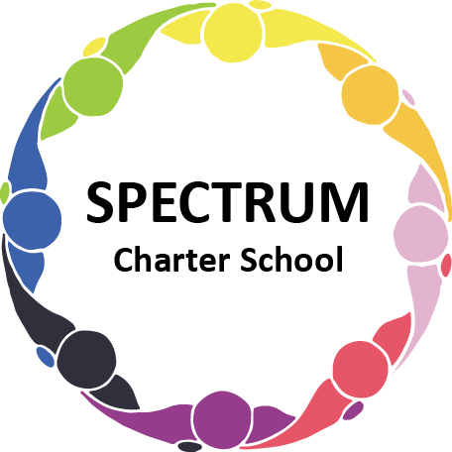

BOARD OF TRUSTEES DISCUSSION AND VOTING MEETING AGENDA
June 22, 2022

DATE: June 22, 2022 TIME: 7:00 PM
LOCATION: Spectrum Charter School- virtual via Google Meet
CEO: Dr. Matthew Erickson

DISCUSSION AGENDA ITEMS

- Call to order:

- Pledge of Allegiance

- Roll call:

- Public Comments on Agenda Items:

- New Business:
  - Nomination of Dr. Arleen Wheat as a Spectrum Charter School Board Member Move to vote ꗃ
  - Nomination of Ken Fulkerson as a Spectrum Charter School Board Member Move to vote ꗃ
  - Discussion Item: Lions Golf Outing - Hole Sponsorship and Foursome - Aug. 20, 2022

- CEO/Principal Report:

- Academic Committee Agenda Items:
  - Emergency Instructional Time Report for PDE Move to vote ꗃ
  - Comprehensive Plan (2022-2025) following a 28-day public review Move to vote ꗃ
  - Waterfront Learning Contract and Pricing Document Move to vote ꗃ

- Finance Committee Agenda Items:
  - Monthly Financial Reports:
    - YTD Activity
    - Tuition aging report
    - Activity Report
    - Budget Vs. Actual
    - Cash Flow
  - Monthly purchase review:
- Amazon orders
- Visa Bills
C. Final 22-23 General Fund Budget Move to vote ꗃ
- Budget Detail
D. Website Proposal
1. Contract
2. Attachment A

- Fundraising/Grants Committee Agenda Items:
- Grant Training

- Facilities Report
- Status report/Proposed plan for building projects
- Zoning of House
- Building project quote

- Personnel Committee Agenda Items:
- 22-23 Employee Contracts Move to vote ꗃ
- ESY Contracts Move to vote ꗃ
- Part-time Physical Education Teacher Posting Move to vote ꗃ
- Teacher posting pending enrollment (43) Move to vote ꗃ

- Policy Committee Agenda Items:

- Public Comments on non-Agenda Items:

- Motion to Adjourn:

VOTING AGENDA ITEMS

- Call to Order:

- Roll Call:

Approval to accept the May 18, 2022 Board of Trustees Meeting minutes as presented.
The Board met in Executive Session on the following date: June 22, 2022. Personnel matters were discussed.

- Public Comments on Agenda Items:

- Academic Committee Agenda Items:
- Motion to Approve Emergency Time Template for PDE
- Motion to approve Waterfront Learning Contract

- Finance Committee Agenda Items:
  - Motion to approve Monthly Financial Reports
  - Motion to pay the bills due through July
  - Motion to approve 22-23 General Fund Budget

- Fundraising/Grants Committee Agenda Items:

- Facilities Report:

- Personnel Committee Agenda Items:
- Motion to approve 22-23 Employee Contracts
- Motion to Approve ESY Contracts

- Policy Committee Agenda Items:

- Public Comments on non-Agenda Items:

- Announcements:

- Next Meeting: August 17, 2022; 7:00 pm; Spectrum Charter School & Google Meet

- Motion to Adjourn:

