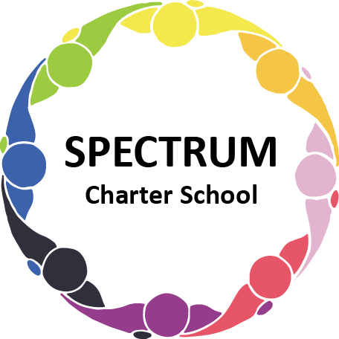

BOARD OF TRUSTEES DISCUSSION AND VOTING MEETING AGENDA
August 17, 2022

DATE: August 17, 2022 TIME: 7:00 PM
LOCATION: Spectrum Charter School- virtual via Google Meet
CEO: Dr. Matthew Erickson

DISCUSSION AGENDA ITEMS

- Call to order:

- Pledge of Allegiance

- Roll call:

- Public Comments on Agenda Items:

- New Business:
  - Discussion Item: Food Services - Plum Borough School District/Parent Survey
  - Board Committees

- CEO/Principal Report:
  - 2022 - Extended School Year
  - 2022-2023 Preparations/Professional Development
  - Current Enrollment
  - Building Projects

- Academic Committee Agenda Items:
- 2022-2023 School Based ACCESS Program Agreement to Participate Move to vote ꗃ
- 2022-2023 Forbes Road Tuition Agreement Move to vote ꗃ
- Emergency Instruction Approval Letter
- Approval for an agreement with Westinghouse Arts Charter School to provide educational services at a rate of $48 per hour pending the review of the proposed contract.
- Comprehensive Plan
- Special Education Audit status
- Waterfront Learning Contract Move to vote ꗃ

- Finance Committee Agenda Items:
  - Monthly Financial Reports:
    - YTD Activity
    - Tuition aging report
    - Activity Report
    - Budget Vs. Actual
    - Cash Flow
  - Monthly purchase review:
- Amazon orders
- Visa Bills
C. Audit renewal
D. Bank proposal (Rate has been increased to 1.14%) Move to vote ꗃ

- Fundraising/Grants Committee Agenda Items:
  - PCCD grant
  - Gift Cards
  - Lions Golf Outing Fundraiser August 20, 2022

- Facilities Report
- Informational Item: Facility Update - House - Improving cosmetics and flooring inside. Plan to move Transition Services and Business Office over upon completion of work.
School Classrooms - Construction concluding soon on two additional classrooms to support growth
- Website Status
- School symbol
- Security Upgrades

- Personnel Committee Agenda Items:
  - Informational Item: PCCD Grant - Pursuing grant funding to support a part-time social worker to support faculty and staff
  - Paraprofessionals
  - STAT Nursing Contract Move to vote ꗃ

- Policy Committee Agenda Items:
A. Health and Safety Plan Move to vote ꗃ

- Public Comments on non-Agenda Items:

- Motion to Adjourn:

VOTING AGENDA ITEMS

- Call to Order:

- Roll Call:

Approval to accept the June 22, 2022 Board of Trustees Meeting minutes as presented.
The Board met in Executive Session on the following date: August 17, 2022.

- Public Comments on Agenda Items:

- Academic Committee Agenda Items:
- Approval of 2022-2023 School Based ACCESS Program Agreement to Participate
- Approval of 2022-2023 Forbes Road Tuition Agreement
- Approval of Waterfront Learning Contract

- Finance Committee Agenda Items:
  - Motion to approve Monthly Financial Reports
  - Motion to pay the bills due through September
  - Motion to approve moving funds to Dollar Bank

- Fundraising/Grants Committee Agenda Items:

- Facilities Report:

- Personnel Committee Agenda Items:
- Approval of Stat Nursing Contract

- New Business:

- Policy Committee Agenda Items:
- Health and Safety Plan

- Public Comments on non-Agenda Items:

- Announcements:

- Next Meeting: September 21, 2022; 7:00 pm; Spectrum Charter School & Google Meet

- Motion to Adjourn:

