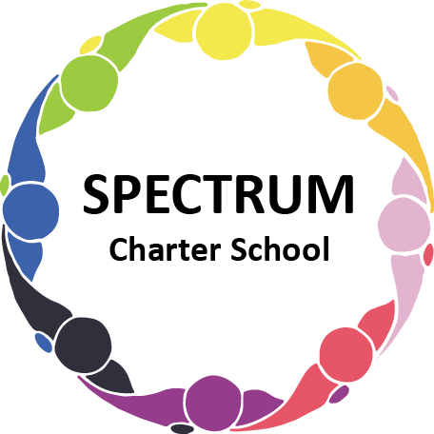

BOARD OF TRUSTEES DISCUSSION AND VOTING MEETING AGENDA
September 21, 2022

DATE: September 21, 2022 TIME: 7:00 PM
LOCATION: Spectrum Charter School- virtual via Google Meet
CEO: Dr. Matthew Erickson

DISCUSSION AGENDA ITEMS

- Call to order:

- Pledge of Allegiance

- Roll call:

- Public Comments on Agenda Items:

- CEO/Principal Report:
- ESY Presentation- Lori
- Autism Caring Center Luncheon
- PCCD Grant
- Lunch Program

VI. Personnel Committee Agenda Items:
- Emergency Substitute Teachers

VII. Academic Committee Agenda Items:
- Approval for an agreement with Westinghouse Arts Charter School to provide educational services at a rate of $48 per hour pending the review of the proposed contract. Move to vote ꗃ

VIII. Finance Committee Agenda Items:
  - Monthly Financial Reports:
    - YTD Activity
    - Tuition aging report
    - Activity Report
    - Budget Vs. Actual
    - Cash Flow
  - Monthly purchase review:
- Amazon orders
- Visa Bills

IX. Fundraising/Grants Committee Agenda Items:

- Lions Golf Outing

X. Facilities Report
- Informational Item: Facility Update - House - Improving cosmetics and flooring inside. Plan to move Transition Services and Business Office over upon completion of work.
- Website Status
- Agreement with Ben McNees to complete construction on classrooms. Move to vote ꗃ
- Agreement with Ben McNees to complete flooring installation in the school and house. Move to vote ꗃ
- PCCD Grant application Move to vote ꗃ

XI. Public Comments on non-Agenda Items:

XII. Motion to Adjourn:

VOTING AGENDA ITEMS

- Call to Order:

- Roll Call:

Approval to accept the August 17, 2022 and September 12, 2022 Board of Trustees Meeting minutes as presented.
The Board met in Executive Session on the following date: September 21, 2022. Student matters were discussed.

- Public Comments on Agenda Items:

- Academic Committee Agenda Items:
- Approval for an agreement with Westinghouse Arts Charter School to provide educational services at a rate of $48 per hour pending the review of the proposed contract.

- Finance Committee Agenda Items:
  - Motion to approve Monthly Financial Reports
  - Motion to pay the bills due through October

- Facilities Report:
- Approval of agreement with Ben McNees to complete construction on classrooms
- Approval of Agreement with Ben McNees to complete floor installation
- Motion to approve the PCCD Grant Application

- Public Comments on non-Agenda Items:

- Announcements:

- Next Meeting: October 19, 2022; 7:00 pm; Spectrum Charter School & Google Meet

- Motion to Adjourn:

