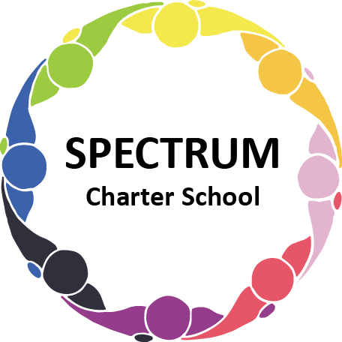

SPECTRUM CHARTER SCHOOL
BOARD OF TRUSTEES SPECIAL VOTING MEETING AGENDA

DATE: February 25, 2022 TIME: 6:00 PM
LOCATION: Google Meet

DISCUSSION/VOTING AGENDA ITEMS

- Call to order
- Pledge of Allegiance

- Roll call
- Public Comments on Agenda items
- Personnel Committee Agenda items
- Scott Domowicz Transition
- John Zahorchak, MBA - Interim Business Manager
- Resume
- Contract
- Stipends

- Facility Committee Agenda items
- Termination of Tevin Davis Contract
- Cleaning Contract Proposals
- Anago Cleaning Systems
- Vanguard Cleaning Systems
- Coverall
- Approval of Cleaning Contractor Contract

- Public comment on non-Agenda items

- Announcements

- Next meeting: March 16, 2022; 7:00 pm; Google Meet
- Motion to adjourn

