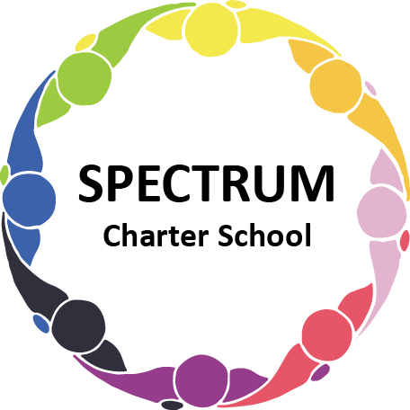

BOARD OF TRUSTEES SPECIAL VOTING MEETING AGENDA
January 17, 2022

DATE: January 17, 2022 TIME: 1:00 PM
LOCATION: ZOOM Meeting

DISCUSSION/VOTING AGENDA ITEMS
- Call to order:
- Pledge of Allegiance

- Roll call
- Public comments on Agenda items

- Personnel Committee Agenda items
- Contract with KeySolution, L.L.C. (Dr. Matthew J. Erickson)
- Attachment A

- Public comment on non-Agenda items
- Announcements
- Next meeting: January 19, 2022; 7:00 pm; Zoom Meeting
- Motion to adjourn

