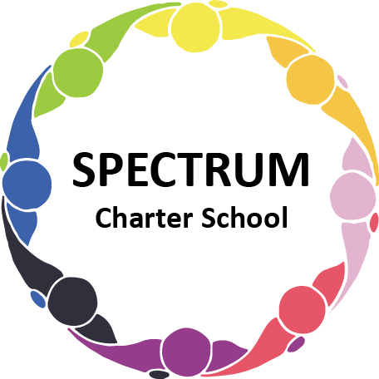

SPECTRUM CHARTER SCHOOL
BOARD OF TRUSTEES SPECIAL VOTING MEETING AGENDA

DATE: September 12, 2022 TIME: 7:00 PM
LOCATION: Google Meet

DISCUSSION/VOTING AGENDA ITEMS

- Call to order
- Pledge of Allegiance

- Roll call
- Public Comments on Agenda items
- Academic Committee Agenda Items
- Westinghouse Contract
- McKeesport SD Transportation Issue

- Facility Committee Agenda items
- Flooring proposal for house
- House painting/hourly rate

- Public comment on non-Agenda items

- Announcements

- Next meeting: September 21, 2022; 7:00 pm; Google Meet
- Motion to adjourn

