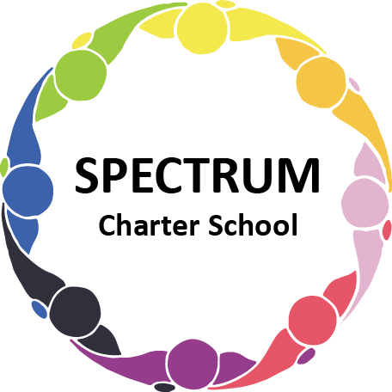

BOARD OF TRUSTEES DISCUSSION AND SPECIAL VOTING MEETING AGENDA
March 21, 2022

DATE: March 21, 2022 TIME: 7:00 PM
LOCATION: Google Meet
CEO: Dr. Matthew Erickson

DISCUSSION AGENDA ITEMS

- Call to order:

- Pledge of Allegiance

- Roll call:

- Public Comments on Agenda Items:

- CEO/Principal Report:

- Academic Committee Agenda Items:
  - Revision to 2021-2022 School Calendar to provide 3/21/2022 is a professional development day Move to vote ꗃ
  - 2022-2023 School Calendar Move to vote ꗃ
  - Curriculum Status
  - Extended School Year (ESY)
  - Requested teachers to create wish list for the fall

- Finance Committee Agenda Items:
  - Introduction of new Business Manager and Business Manager Report
  - Monthly Financial Reports:
    - Financial Position
    - Tuition received
    - Vendor Payments
    - Budget Vs. Actual
    - Cash Flow
  - Monthly purchase review:
- Amazon orders
- Visa Bills
D. Preliminary Budget Status
- Tuition Review

- Marketing/Grants Committee Agenda Items:
A. Fundraising
1. Fundraising Plan Proposal
2. Letters to individual donors
3. Amazon Smile
4. Race Cancellation Status

- Facilities Report
- Anago Contract
- Van Repair

- Personnel Committee Agenda Items:
  - Reviewing Need for Additional Paraprofessional
  - Contract with Grade Point Resources Move to vote ꗃ

- Policy Committee Agenda Items:
- Mask Policy/Health and Safety Plan Move to vote ꗃ

- Public Comments on non-Agenda Items:

- Motion to Adjourn:

VOTING AGENDA ITEMS

- Call to Order:

- Roll Call:

Approval to accept the January 17, 2022, February 16, 2022 and February 25, 2022 Board of Trustees Meeting minutes as presented.
The Board met in Executive Session on the following date: February 25, 2022. Personnel matters were discussed.

- Public Comments on Agenda Items:

- Academic Committee Agenda Items:
- Approval of revision to 2021-2022 School Calendar to provide 3/21/2022 is a professional development day
- Approval of 2022-2023 School Calendar

- Finance Committee Agenda Items:
  - Motion to approve Monthly Financial Reports
  - Motion to pay the bills due through March

- Fundraising/Grants Committee Agenda Items:

- Personnel Committee Agenda Items:
- Motion to approve Contract with Grade Point Resources

- Policy Committee Agenda Items:
A. Approval of Mask Policy/Health and Safety Plan

- Public Comments on non-Agenda Items:

- Announcements:

- Next Meeting: April 20, 2022; 7:00 pm; Google Meet

- Motion to Adjourn:

