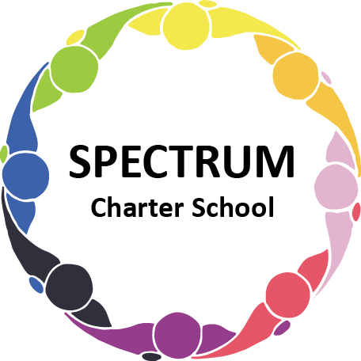

BOARD OF TRUSTEES SPECIAL VOTING MEETING AGENDA
JULY 29, 2021

DATE: July 29, 2021 TIME: 6:00 PM
LOCATION: Spectrum Charter School Multi-Purpose Room
CEO: Dr. Gail Yamnitzky

SPECIAL VOTING MEETING AGENDA ITEMS

- Call to order:

- Roll call

The Board met in Executive Session on July 29, 2021 to discuss matters of personnel.

- Public comments on Agenda items

- Academic Committee Agenda items
  - Approval of the Charter School Annual Report as presented
  - Approval of Updated Health & Safety Plan

- Finance Committee Agenda items
  - Approval of contract with Grade Point Resources to provide professional development to teachers and paraprofessionals

- Fundraising/Grants Committee Agenda items

- Personnel Committee Agenda items
  - Approval of the Personnel Agenda as presented

- Policy Committee Agenda items

- Public comment on non-Agenda items

- Announcements

- Next meeting

- Motion to adjourn

