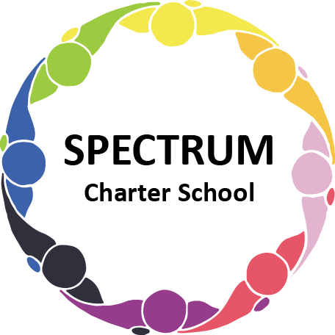

BOARD OF TRUSTEES DISCUSSION AND VOTING MEETING AGENDA
January 10, 2023

DATE: January 10, 2023 TIME: 7:00 PM
LOCATION: Spectrum Charter School- virtual via Google Meet
CEO: Dr. Matthew Erickson

DISCUSSION/VOTING AGENDA ITEMS

- Call to order:

- Pledge of Allegiance

- Roll call:

Approval to accept the December 5, 2022 Board of Trustee Meeting Minutes as presented. The Board Met in Executive Session on the following dates: December 13, 2022.

- Public Comments on Agenda Items:

- CEO/Principal Report:
  - Welcome Jessica Ewing and Alexis Graham
  - Student Council Election Results and Plans
  - Winter Dance

VI. Personnel Committee Agenda Items:
- Motion to approve the Teacher Contract for Jessica Ewing
- Motion to approve the proposal for ESY 2023
- Motion to approve the addendum to the Grade Point Resources contract to provide counseling services

VII. Academic Committee Agenda Items:
- Settlement Agreement
1. Board Action
- Board Resolution
1. Board Action

VIII. Finance Committee Agenda Items:
- Monthly Financial Reports:
    - Monthly Financial Reports:
    - YTD Activity
    - Tuition aging report
    - Expense Report
    - Budget Vs. Actual
    - Cash Flow
B. Monthly purchase review:
- Amazon orders
- Visa Bill
C. Review of Bank accounts and interest on bank accounts
D. Board Action: Approval to pay bills due through February
E. Board Action: Approve assigning $400,000 from unassigned fund balance for future obligations

IX. Fundraising/Grants Committee Agenda Items:
- Update on Giving Tuesday

X. Facilities Report
- Update on PCCD grant
- Website Update/Demonstration
- Update on carpet and pipes
- Food Services

XI. Public Comments on non-Agenda Items:

XII. Announcements:

XIII. Next Meeting: February 14, 2023; 7:00 pm; Spectrum Charter School & Google Meet

XIV. Motion to Adjourn:

