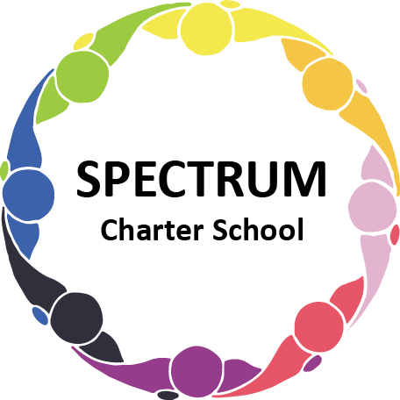

BOARD OF TRUSTEES DISCUSSION AND VOTING MEETING AGENDA
March 14, 2023

DATE: March 14, 2023 TIME: 7:00 PM
LOCATION: Spectrum Charter School- virtual via Google Meet
CEO: Dr. Matthew Erickson

DISCUSSION/VOTING AGENDA ITEMS

- Call to order:

- Pledge of Allegiance

- Roll call:

Approval to accept the February 14, 2023 Board of Trustee Meeting Minutes as presented. The Board Met in Executive Session on the following date: March 14, 2023

- Public Comments on Agenda Items:

- CEO/Principal Report:
  - Enrollment
  - Website
  - St. Patrick’s Day Dance
  - Facilities Update

VI. Personnel Committee Agenda Items:
- Proposal for a Maintenance Position
Board Action:
- Food Services Part-Time Position
Board Action:
- Paraprofessionals

VII. Academic Committee Agenda Items:
  - 2023-2024 School Calendar- Draft
  - Physical Education Part-time Position
Board Action:

VIII. Finance Committee Agenda Items:
- Monthly Financial Reports:
    - Monthly Financial Reports:
    - Monthly Activity
    - Tuition aging report
    - Expense Report
    - Budget Vs. Actual
    - Cash Flow
    - Reconciled Bank accounts
      - PNC General
      - PNC Capital
      - Dollar Bank General
B. Monthly purchase review:
- Amazon orders
- Visa Bill
C. Approval to pay bills due through April
Board Action:
D. Advertising Proposals
Board Action:

IX. Fundraising/Grants Committee Agenda Items:
- Update on PA Coalition Grant
- Highmark Grant
- Color the Spectrum Grant
- Raise Right
- Open House Event

X. Facilities Report
- Website Update
- Architecture Firms
- Garden Materials for Earth Day
Board Action:
- House Refrigerator
- PCCD Grant
  - Security System
  - Door Replacement
- Bedroom Donation
- Facility Priority list
XI. Policy Committee
- Parent/Student Handbook
Board Action:

XII. Public Comments on non-Agenda Items:

XIII. Announcements:

XIV. Next Meeting: April 18, 2023; 7:00 pm; Spectrum Charter School & Google Meet

XV. Motion to Adjourn:

