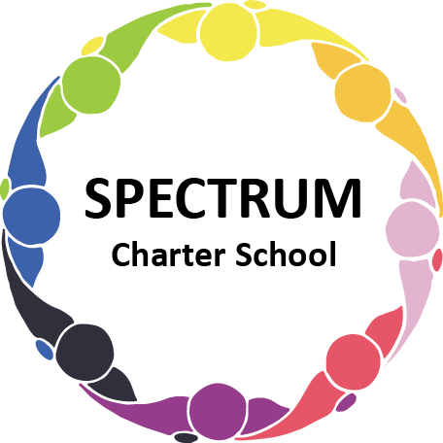

SPECTRUM CHARTER SCHOOL
BOARD OF TRUSTEES SPECIAL VOTING MEETING AGENDA

DATE: March 30, 2023 TIME: 7:00 PM
LOCATION: Google Meet

DISCUSSION/VOTING AGENDA ITEMS

- Call to order
- Pledge of Allegiance

- Roll call
- Public Comments on Agenda items:

- Personnel Committee Agenda items:
- Approval of the Personnel Report
- Salary adjustment for Mary Snyder for class coverage
- Additional compensation for Natalie Picone for class coverage

- Fundraising/Grants Committee Agenda Items:
- Approval to seek the PA Coalition of Charter Schools Grant

VII. Facilities:
- Approval of Kapp Service Proposal for phone and internet

VIII. Research Request
- Slippery Rock University Doctoral Student

IX. Public comment on non-Agenda items:

X. Announcements:

XI. Next meeting: April 18, 2023; 7:00 pm; Google Meet

XII. Motion to Adjourn

