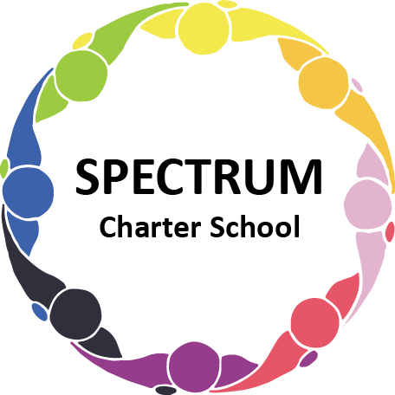

BOARD OF TRUSTEES DISCUSSION AND VOTING MEETING AGENDA
May 16, 2023

DATE: May 16, 2023 TIME: 7:00 PM
LOCATION: Spectrum Charter School- virtual via Google Meet
CEO: Dr. Matthew Erickson

DISCUSSION/VOTING AGENDA ITEMS

- Call to order:

- Pledge of Allegiance

- Roll call:

Approval to accept the April 18,2023 Board of Trustee Meeting Minutes as presented. The Board met in Executive Session on May 16, 2023.

- Public Comments on Agenda Items:

- CEO/Principal Report:
  - Open House - 4/25/23
  - Visit from Dr. Anne Clark - CEO - PA Coalition of Charter Schools - 5/25
  - Prom - May 20, 2023
  - Enrollment Update

VI. Personnel Committee Agenda Items:
- Grade Point Resources Contract
- Approval of the Community-Based Experience Coordinator position
- 23-24 Employee Contracts

VII. Academic Committee Agenda Items:
  - Art/Music/Physical Education Contract
  - Recommendation to cap enrollment for the 2023-2024 school year at 54 students

VIII. Finance Committee Agenda Items:
- Monthly Financial Reports:
    - Monthly Financial Reports:
    - Monthly Activity
    - Tuition aging report
    - Expense Report
    - Budget Vs. Actual
    - Cash Flow

B. Monthly purchase review:
- Amazon orders
- Visa Bill
C. Proposed Final Budget
D. Approval to pay bills due through June
Board Action:

IX. Fundraising/Grants Committee Agenda Items:
- Review of Grants

X. Public Comments on non-Agenda Items:

XI. Announcements:

XII. Next Meeting: June 20, 2023; 7:00 pm; Spectrum Charter School & Google Meet

XIII. Motion to Adjourn:

