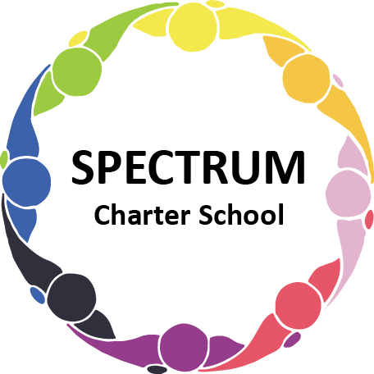

BOARD OF TRUSTEES DISCUSSION AND VOTING MEETING AGENDA
August 15, 2023

DATE: August 15, 2023 TIME: 7:00 PM
LOCATION: Spectrum Charter School- virtual via Google Meet
CEO: Dr. Matthew Erickson

DISCUSSION/VOTING AGENDA ITEMS

- Call to order:

- Pledge of Allegiance

- Roll call:

Approval to accept the June 20, 2023 Board of Trustee Meeting Minutes as presented. Board met in Executive Session on August 15 to discuss personnel matters.

- Public Comments on Agenda Items:

- CEO/Principal Report:
  - Enrollment
  - Extended School Year
  - Professional Development
  - Annual Report - Submitted
  - Curriculum Update
  - Flexible Instruction Days (FID)

VI. Personnel Committee Agenda Items:

- Recommendation for the hiring of Denise Barrett, Paraprofessional for the 2023-2024 academic year
a. Board Action:
- Recommendation for the hiring of Christopher Richardson, Paraprofessional for the 2023-2024 academic year
  - Board Action:
- Recommendation for the hiring of a Behavior Specialist, Paraprofessional for the 2023-2024 academic year
  - Board Action:
- Recommendation for the approval of the Proposed Agreement and Statement of Work with DL Tech Solutions, LLC to provide technology services
  - Board Action:
- Recommendation for the approval of the proposed agreement with KeySolution Staffing for School Psychology services
- Board Meeting Dates - 2023-2024
  - August 15
  - September 19
  - October 17
  - November 21
  - December 19
  - January 16
  - February 20
  - March 19
  - April 16
  - May 21
  - June 18

VII. Academic Committee Agenda Items:
  - Status update of a Dual Enrollment agreement with the Community College of Allegheny County
  - AIU 2023-2024 Comprehensive Services Agreement and pricing guide
- Board Action:
  - 2023-2024 Forbes Road Tuition Agreement
- Board Action:

VIII. Finance Committee Agenda Items:
- Monthly Financial Reports:
    - Monthly Financial Reports:
    - Monthly Activity
    - Tuition aging report (Discussion)
    - Expense Report
    - Budget Vs. Actual
    - Cash Flow

B. Monthly purchase review:
- Amazon orders
- Visa Bills
C. Approval to pay bills due through September
Board Action:
D. Audit renewal
a. Board Action:

IX. Fundraising/Grants Committee Agenda Items:
- The Greensburg Foundation Grant - Submitted ($20,000): Application
  - Board Action:
- Highmark Grant Application: Denied
- Recommendation to create a Foundation for Spectrum Charter School
  - Board Action:

X. Facilities Report
- Update regarding municipal code for the house

XI. Public Comments on non-Agenda Items:

XII. Announcements:

XIII. Next Meeting: September 19, 2023; 7:00 pm; Spectrum Charter School & Google Meet

XIV. Motion to Adjourn:

