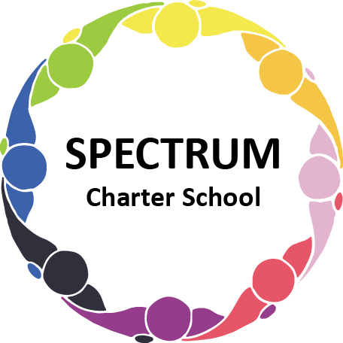

BOARD OF TRUSTEES DISCUSSION AND VOTING MEETING AGENDA
September 19, 2023

DATE: September 19, 2023 TIME: 7:00 PM
LOCATION: Spectrum Charter School- virtual via Google Meet
CEO: Dr. Matthew Erickson

DISCUSSION/VOTING AGENDA ITEMS

- Call to order:

- Pledge of Allegiance

- Roll call:

Approval to accept the August 15, 2023 Board of Trustee Meeting Minutes as presented. Board met in Executive Session on August 31, 2023 to discuss personnel matters.

- Public Comments on Agenda Items:
- Board Matters
  - Resignation of Ms. Seana Banks from the Board of Trustees
  - Nomination of Dr. Jonathan Duval as a Board of Trustees member
    - Board Action:
  - Policies
    - Tuition Reimbursement Policy recommendation for approval

- CEO/Principal Report:
  - Enrollment/Change in Regulations
  - Meet the Teacher Night - 9/19/2023
  - Field Trip - Pittsburgh Zoo - 10/13/2023
  - Gateway School District Administrative Meeting
  - Safety Drills

VII. Personnel Committee Agenda Items:

- Recommendation for the hiring of Tyrone Neal, Behavior Specialist for the 2023-2024 academic year
  - Board Action:
- Recommendation for the hiring of George Dollish, driver for temporary service for the 2023-2024 academic year
  - Board Action:

VIII. Academic Committee Agenda Items:
  - Informational Item: HMH curricular materials for the 2023-2024 academic year

IX. Finance Committee Agenda Items:
- Monthly Financial Reports:
    - Monthly Financial Reports:
    - Monthly Activity
    - Expense Report
    - Budget Vs. Actual
    - Cash Flow

B. Monthly purchase review:
- Amazon orders
- Visa Bill

C. Approval to pay bills due through October
Board Action:

X. Fundraising/Grants Committee Agenda Items:
- Planning for Giving Tuesday
- Generating ideas for future fundraising events

XI. Facilities Report
- Boiler Repairs
- Air Conditioning - Transition Building

XII. Public Comments on non-Agenda Items:

XIII. Announcements:

XIV. Next Meeting: October 17, 2023; 7:00 pm; Spectrum Charter School & Google Meet

XV. Motion to Adjourn:

