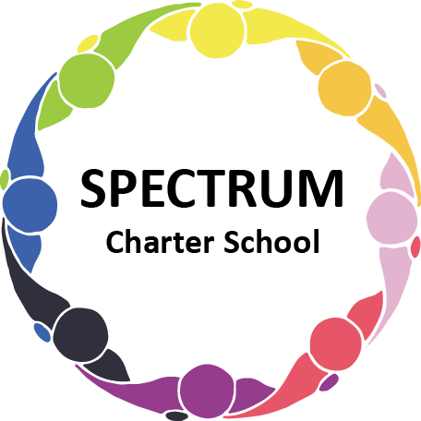

BOARD OF TRUSTEES DISCUSSION AND VOTING MEETING AGENDA
October 17, 2023

DATE: October 17, 2023 TIME: 7:00 PM
LOCATION: Spectrum Charter School- virtual via Google Meet
CEO: Dr. Matthew Erickson

DISCUSSION/VOTING AGENDA ITEMS

- Call to order:

- Pledge of Allegiance

- Roll call:

Approval to accept the September 19, 2023 Board of Trustee Meeting Minutes as presented. Board met in Executive Session on October 17, 2023 to discuss personnel matters.

- Public Comments on Agenda Items:

- CEO/Principal Report:
  - Student Council
  - Breakfast Program
  - Fall Dance Event - 10/27/23
  - Build On Event - 11/17/23
  - Safety Drills - October

VI. Personnel Committee Agenda Items:

- Approval of Marissa Helinski (Point Park University) to complete her student teaching requirements with Mrs. Lori Yurkovich from January 9 to April 19, 2023.
Board Action:

VII. Academic Committee Agenda Items:
  - Curriculum Status
  - Motion to approve up to $10,000 for the purchase of SMART Boards
Board Action:

VIII. Finance Committee Agenda Items:
- Monthly Financial Reports:
    - Monthly Financial Reports:
    - Monthly Activity
    - Expense Report
    - Budget Vs. Actual
    - Cash Flow

B. Monthly purchase review:
- Amazon orders
- Visa Bill

C. Approval to pay bills due through November
Board Action:

IX. Fundraising/Grants Committee Agenda Items:
- Giving Tuesday

X. Facilities Report
- Boiler repairs
- House air conditioning

XI. Public Comments on non-Agenda Items:

XII. Announcements:

XIII. Next Meeting: November 21, 2023; 7:00 pm; Spectrum Charter School & Google Meet

XIV. Motion to Adjourn:

