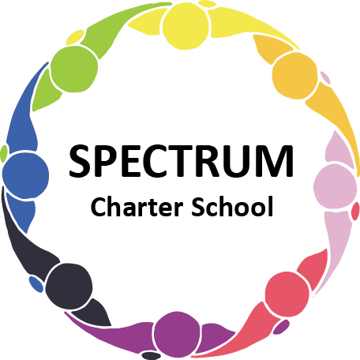

BOARD OF TRUSTEES DISCUSSION AND VOTING MEETING AGENDA
November 21, 2023

DATE: November 21, 2023 TIME: 7:00 PM
LOCATION: Spectrum Charter School- virtual via Google Meet
CEO: Dr. Matthew Erickson

DISCUSSION/VOTING AGENDA ITEMS

- Call to order:

- Pledge of Allegiance

- Roll call:

Approval to accept the October 17, 2023 Board of Trustee Meeting Minutes as presented. Board met in Executive Session on November 21,2023 to discuss personnel matters.

- Public Comments on Agenda Items:

- CEO/Principal Report:
  - Student Council - Guest Speaker
  - Breakfast Program Up and Running!
  - Planning a Semi-Formal Event
  - Build On Event - 11/17/23
  - Giving Thanks - Gift Cards
  - Current Enrollment

VI. Personnel Committee Agenda Items:

None

VII. Academic Committee Agenda Items:
- Curriculum Update

VIII. Finance Committee Agenda Items:
- Monthly Financial Reports:
    - Monthly Financial Reports:
    - Monthly Activity
    - Expense Report
    - Budget Vs. Actual
    - Cash Flow

B. Monthly purchase review:
- Amazon orders
- Visa Bill

C. Approval to pay bills due through December
Board Action:

IX. Fundraising/Grants Committee Agenda Items:
- Giving Tuesday

X. Facilities Report
- Maintenance Schedule
- Motion to approve the estimate from Tri-State Roofing Solutions to replace the lower roof of the school building, subject to a review of the contract by counsel.
Board Action:
- Motion to approve the Sonitrol proposal for additional cameras and wireless bridge for house cameras, Option 1 contract addendum, pending legal review.
Board Action:

XI. Public Comments on non-Agenda Items:

XII. Announcements:

XIII. Next Meeting: December 19, 2023; 7:00 pm; Spectrum Charter School & Google Meet

XIV. Motion to Adjourn:

