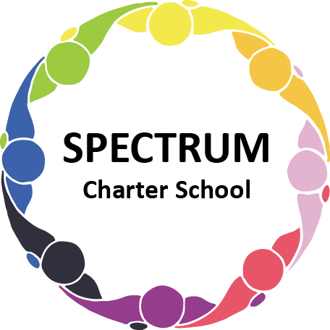

BOARD OF TRUSTEES DISCUSSION AND VOTING MEETING AGENDA
December 19, 2023

DATE: December 19, 2023 TIME: 7:00 PM
LOCATION: Spectrum Charter School- virtual via Google Meet
CEO: Dr. Matthew Erickson

DISCUSSION/VOTING AGENDA ITEMS

- Call to order:

- Pledge of Allegiance

- Roll call:

Approval to accept the November 21, 2023 Board of Trustee Meeting Minutes as presented. Board met in Executive Session on December 19, 2023 to discuss personal and student matters.

- Public Comments on Agenda Items:

- CEO/Principal Report:
  - Semi-formal event
  - Student Council Update
  - Congratulations Larson!
  - Toys for Tikes
  - Current Enrollment
- Election of Board of Trustees and Officers
  - School Board
    - Nomination of Trustees
      - Michele Gutman
      - Barb Bain
    - Board Action:
    - Nomination of Officers
      - President: Ellen Szczerba
      - Vice President: Michele Gutman
      - Secretary: Dorice Tharp
      - Treasurer: Tammy Goda
    - Board Action:
  - Foundation
    - Nomination of Trustees
      - Michele Gutman
      - Ellen Szczerba
      - Dorice Tharp
      - Barb Bain
      - Tammy Goda
      - Arleen Wheat
      - Jonathan Duvall
    - Board Action:
    - Nomination of Officers
      - President: Michele Gutman
      - Vice President: Ellen Szczerba
      - Secretary: Arleen Wheat
      - Treasurer: Jonathan Duvall
    - Board Action:

VII. Personnel Committee Agenda Items:

- Employment of Stephen Fishman effective December 14, 2023 as a Physical Education/Health teacher
  - Board Action:

VIII. Academic Committee Agenda Items:
- Curriculum Update/Proposal

IX. Finance Committee Agenda Items:
- Monthly Financial Reports:
    - Monthly Financial Reports:
    - Monthly Activity
    - Expense Report
    - Budget Vs. Actual
    - Cash Flow

B. Monthly purchase review:
- Amazon orders
- Visa Bill

C. Approval to pay bills due through January
Board Action:

D. Review of Draft Annual Financial Statements and 990 Form -Peter Vancheri

X. Fundraising/Grants Committee Agenda Items:
- January 17th - Max & Erma’s event Fundraiser
XI. Facilities Report
A. No Report

XII. Policy
- Revision of Abuse Policy
  - Board Action

XIII. Public Comments on non-Agenda Items:

XIV. Announcements:

XV. Next Meeting: January 16, 2024; 7:00 pm; Spectrum Charter School & Google Meet

XVI. Motion to Adjourn:

