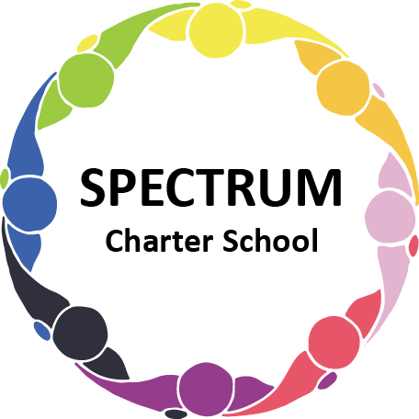

BOARD OF TRUSTEES DISCUSSION AND VOTING MEETING AGENDA
January 16, 2024

DATE: January 16, 2024 TIME: 7:00 PM
LOCATION: Spectrum Charter School and virtual via Google Meet
CEO: Dr. Matthew Erickson

DISCUSSION/VOTING AGENDA ITEMS

- Call to order:

- Pledge of Allegiance

- Roll call:

Approval to accept the December 19, 2023 Board of Trustee Meeting Minutes as presented. Board met in Executive Session on January 16, 2024 to discuss personal and student matters.

- Public Comments on Agenda Items:

- CEO/Principal Report:
  - Semi-formal event
  - Max & Erma’s Fundraiser event - 1/17/24
  - Current Enrollment

VI. Personnel Committee Agenda Items:

- No report

VII. Academic Committee Agenda Items:
- Curriculum Update

VIII. Finance Committee Agenda Items:
- Monthly Financial Reports:
    - Monthly Financial Reports:
    - Monthly Activity
    - Expense Report
    - Budget Vs. Actual
    - Cash Flow

B. Monthly purchase review:
- Amazon orders
- Visa Bill

C. Approval to pay bills due through February
Board Action:

D. Final Annual Financial Statements

E. Approval to remove Dorice Tharp and add Tammy Goda as a signer to Spectrum Charter School’s PNC and Dollar Bank accounts
Board Action:

IV. Fundraising/Grants Committee Agenda Items:
- January 17th - Max & Erma’s event Fundraiser
- Foundation Update
X. Facilities Report
A. Window Update

XI. Public Comments on non-Agenda Items:

XII. Announcements:

XIII. Next Meeting: February 20, 2024; 7:00 pm; Spectrum Charter School & Google Meet

XIV. Motion to Adjourn:

