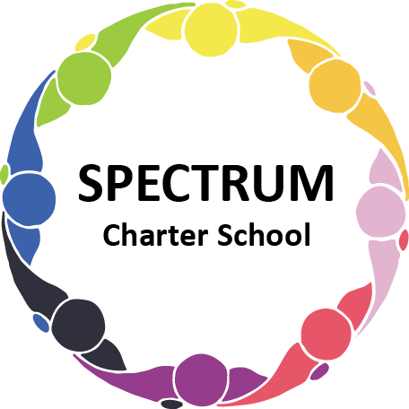

BOARD OF TRUSTEES DISCUSSION AND VOTING MEETING AGENDA
February 20, 2024

DATE: February 20, 2024 TIME: 7:00 PM
LOCATION: Spectrum Charter School and virtual via Google Meet
CEO: Dr. Matthew Erickson

DISCUSSION/VOTING AGENDA ITEMS

- Call to order:

- Pledge of Allegiance

- Roll call:

Approval to accept the January 16, 2024 Board of Trustee Meeting Minutes as presented. Board met in Executive Session on February 20, 2024 to discuss personal and student matters.

- Public Comments on Agenda Items:

- CEO/Principal Report:
  - Semi-formal event/Parent Social
  - Max & Erma’s Fundraiser event - 1/17/24 Results
  - Field Trip - 2/1
  - Transition Update
  - Current Enrollment

VI. Personnel Committee Agenda Items:
- Informational item-Behavioral Specialist & Paraprofessional positions
- Accept the resignation of TJ Neal effective 2/16/2024
- Motion to approve Lori Yurkovich for Instruction in the Home at an hourly rate of $45.00 per hour

VII. Academic Committee Agenda Items:
- Motion to approve the 2024-2025 Academic Calendar
- Motion to approve the 24-25 Board Meeting Dates
- Motion to approve the 2024 ESY proposal
- Motion to approve the student agreement with Longmore Academy

VIII. Policy Committee Agenda Items:
- Motion to approve the updated Confidentiality Statement
- Motion to accept the review of the Conflict of Interest policy
- Informational Item: Committee Assignments:
  - Finance & Facilities Dorice Tharp & Tammy Goda
  - Academic & Curriculum Barb Bain & Arleen Wheat
  - Personnel, Student Services Ellen Szczerba & Michele Gutman
  - Grants & Fundraising Jon Duvall & Ellen Szczerba

IX. Finance Committee Agenda Items:
- Monthly Financial Reports:
    - Monthly Financial Reports:
    - Monthly Activity
    - Expense Report
    - Budget Vs. Actual
    - Cash Flow
B. Monthly purchase review:
- Amazon orders
- Visa Bill
C. Approval to pay bills due through March
Board Action:

X. Fundraising/Grants Committee Agenda Items:
- Foundation Update
- Motion to approve the opportunity to seek the following grants
A. Next for Autism
B. Highmark
C. Dollar Bank Foundation
D. BNY Mellon Foundation
E. Max and Victoria Dreyfus Foundation
F. PPCD Grant

XI. Facilities Report
A. Motion to approve a quote to repair and install a badge system for interior doors through
Sonitrol as quoted

XII. Public Comments on non-Agenda Items:

XIII. Announcements:

XIV. Next Meeting: March 19, 2024; 7:00 pm; Spectrum Charter School & Google Meet

XV. Motion to Adjourn:

