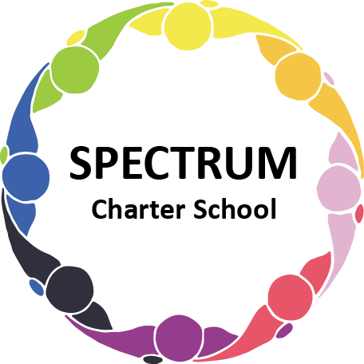

BOARD OF TRUSTEES DISCUSSION AND VOTING MEETING AGENDA
March 19, 2024

DATE: March 19, 2024 TIME: 7:00 PM
LOCATION: Spectrum Charter School and virtual via Google Meet
CEO: Dr. Matthew Erickson

DISCUSSION/VOTING AGENDA ITEMS

- Call to order:

- Pledge of Allegiance

- Roll call:

Approval to accept the February 20, 2024 Board of Trustee Meeting Minutes as presented. Board met in Executive Session on March 19, 2024 to discuss personal and student matters.

- Public Comments on Agenda Items:

- CEO/Principal Report:
  - Upcoming Events
  - Women’s History Month
  - Current Enrollment
  - Curriculum Update

VI. Personnel Committee Agenda Items:
- Motion to hire Stephanie Gresh, Behavior Specialist for the remainder of the 2023-2024 academic year.
- Motion to approve a transportation agreement for staff drivers
- Motion to approve the agreement with KeySolution Staffing for transportation
- Motion to approve a related services agreement with River Therapies for the 2024-2025 academic year
- Motion to approve the Business Manager agreement with KeySolution Staffing for the 2024-2025 academic year
- Motion to approve the Facilities Consultant agreement with KeySolution Staffing for the 2024-2025 academic year

VII. Academic Committee Agenda Items:
- Motion to revise the Tuition Agreement with CCAC

VIII. Policy Committee Agenda Items:
- Motion to approve the 2024-2028 Strategic Plan

IX. Finance Committee Agenda Items:
- Monthly Financial Reports:
    - Monthly Activity
    - Expense Report
    - Budget Vs. Actual
    - Cash Flow
B. Monthly purchase review:
- Amazon orders
- Visa Bill
C. Approval to pay bills due through April
Board Action:

X. Fundraising/Grants Committee Agenda Items:
- Foundation Update

XI. Facilities Report
A. Sonitrol Update

XII. Public Comments on non-Agenda Items:

XIII. Announcements:

XIV. Next Meeting: April 16, 2024; 7:00 pm; Spectrum Charter School & Google Meet

XV. Motion to Adjourn:

