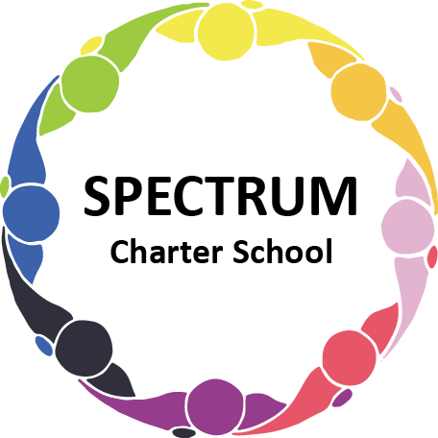

BOARD OF TRUSTEES DISCUSSION AND VOTING MEETING AGENDA

September 17, 2024

DATE: September 17, 2024 TIME: 7:00 PM

LOCATION: Virtual via Google Meet

CEO: Dr. Matthew Erickson

**DISCUSSION/VOTING AGENDA ITEMS**

1. **Call to order:**
2. [Pledge of Allegiance](https://docs.google.com/presentation/d/1SN9Qqhviqr1qN0vdLI1ImPSyoTezCWzXiNOZRf45h4M/edit?usp=sharing)
3. **Roll call:**

Approval to accept the [August 20,2024](https://drive.google.com/file/d/11d6D9lir3EQMB5T7sNY0k82gA0NfZYJd/view?usp=sharing) Board of Trustee Meeting Minutes as presented. The Board met in Executive Session on September 17, 2024.

1. **Public Comments on Agenda Items:**
2. **CEO/Principal Report:**
   1. Highlights
      1. Meet the Teacher/Staff Night
      2. Continuation of safety enhancements
      3. Recognition of nominees for PA Coalition of Public Charter Schools Legacy Awards:
         1. Mr. Roger Stedina - Teacher
         2. Mrs. Lori Yurkovich - Rising Star School Leader
         3. Mrs. Barb Bain - Lifetime Achievement
         4. Mrs. Ellen Szczerba - School Board Member
   2. Current Enrollment

**VI. Personnel Committee Agenda Items:**

1. Motion to approve the [resolution](https://drive.google.com/file/d/1I84asO4MjNtUFBgIgyCUcWZyz_EYALIU/view?usp=sharing) for PSERS regarding the CEO/Principal.

**VII. Academic Committee Agenda Items:**

1. None

**VIII. Policy Committee Agenda Items:**

1. Informational Item: Construction of the Comprehensive Planning Team
2. Informational Item: Review of the SCS Strategic Plan
3. Motion to approve revisions to the [Title IX Nondiscrimination Policy](https://drive.google.com/file/d/1sQeUJc4B5jB-U9-Sa-vK1p_bpFakasbl/view?usp=sharing)
4. Motion to approve revisions to the [Title IX Grievance Procedures](https://drive.google.com/file/d/1Y3EiyQH82klojlaDVnDPFhjQ4R1JKrSj/view?usp=sharing)

**IX. Committee Reports**

1. Finance/Facilities (Dorice/Tammy)
2. Academics/Curriculum (Arleen/Barb)
3. Personnel/Student Services (Michele/Ellen)
4. Grants/Fundraising (Jonathan/Ellen)
5. Strategic Plan Quarterly Review

**X. Finance Committee Agenda Items:**

1. Monthly Financial Reports:
   * 1. [Statement of Activity](https://drive.google.com/file/d/1-umjLaX-4hzZYGuojg9fDbYqfwJnm0CX/view?usp=sharing)
     2. [Expense Report](https://drive.google.com/file/d/1kCg4bIIUSXzx_5f_y9loTY5UfYbPnzsI/view?usp=sharing)
     3. [Budget Vs. Actual](https://drive.google.com/file/d/11y99QSFtigfKyWHjdsEFItEx5P0d6OHP/view?usp=sharing)
     4. [Cash Flow](https://drive.google.com/file/d/1R2TgA9a4BxAEPvKtS01v7ZC-4XCMv61t/view?usp=sharing)

B. Monthly purchase review:

1. [Amazon orders](https://drive.google.com/file/d/1IC-aPIr85w35Q0V-rA5HkytoAEuE9PMy/view?usp=sharing)
2. [Visa Bill](https://drive.google.com/file/d/1kIdVPjX2L_u0jkZKMwS5xMnLsIs92JAf/view?usp=sharing)

C. Approval to pay bills due through October

Board Action:

D. Motion to approve [Audit Renewal](https://drive.google.com/file/d/1eTfbDyInLeQzACVfcTGDHNebRc3bpd_Z/view?usp=sharing)

**XI. Fundraising/Grants Committee Agenda Items:**

1. Safety Grant Proposals

**XII. Facilities Report**

A. Informational Items: Summer Project Updates

1. Informational Item: Darryl Yonkers

**XIII. Public Comments on non-Agenda Items:**

**XIV. Announcements:**

**XV. Next Meeting: October 15, 2024; 7:00 pm; Spectrum Charter School & Google Meet**

**XVI. Motion to Adjourn:**