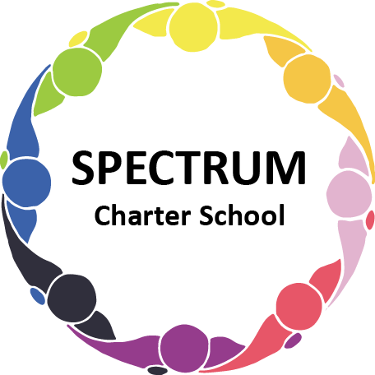

SPECTRUM CHARTER SCHOOL
BOARD OF TRUSTEES SPECIAL VOTING MEETING AGENDA

DATE: August 24, 2026 TIME: 7:00 PM
LOCATION: Google Meet

DISCUSSION/VOTING AGENDA ITEMS

- Call to order
- Pledge of Allegiance

- Roll call

- Public Comments on Agenda items:

- CEO/Principal Report:

VI. Personnel Committee Agenda Items:
- Motion to approve the contractual agreement with Bramlet Enterprises LLC to provide a security officer for the 2026-2027 academic year
- Motion to accept the resignation of Jenny Elliott, Licensed Practical Nurse for the 2026-2027 academic year

VII. Finance Committee Agenda Items:
- Motion to approve MGI Risk Management as our BOR and the acceptance to bind the Philadelphia package, vacant building policy, and workers compensation

VIII. Public comment on non-Agenda items:

IX. Announcements:

X. Next meeting: September 15, 2026; 7:00 pm; Spectrum Charter School & Google Meet

XI. Motion to Adjourn

